**Design Requirements**

* Languages: React, html, css
* I need web design for a page. It has several subpages. Mainly a list of places, a login and a register user page.
* The design should not be over-the-top, no crazy colours, simple and good-looking.
* Ex:
* I only need design – all backend parts will be handled by me.
* **For the Places page**
* The “places” will need to be several react Components. Here is a mockup of the data that needs to be shown.  
  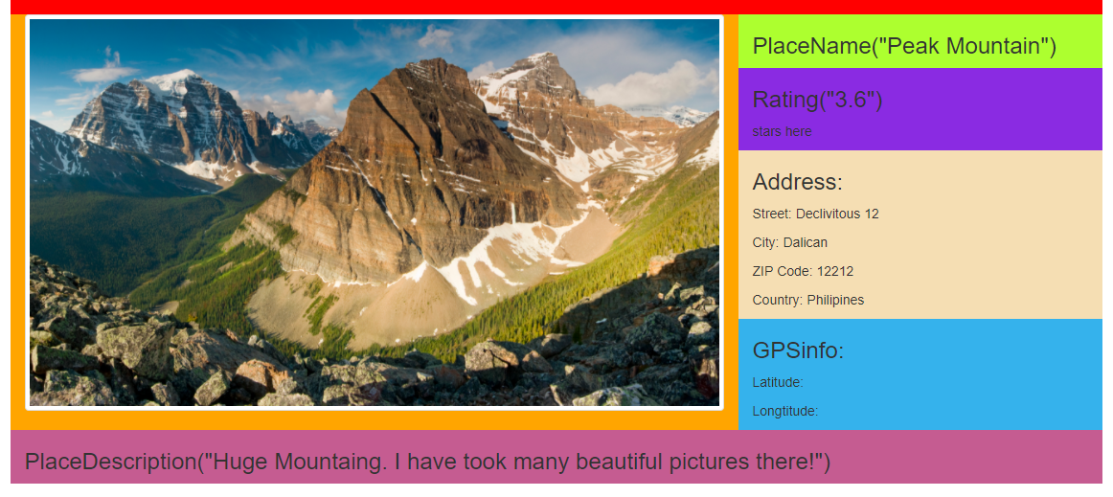
* This is an example of the data that needs to be presented. (not with these colors)
* We need inputs to search and filter – I will handle the functionality, but the fields needs to be there. These needs to be either on the side or on the top, but following the scroll down the page.
* We need the backgrounds for the component for places to be the same.
* If a part is empty, like gps in the picture, it needs to be hidden, and address should be expanded.
* You must also design a page with a login component. Again, Only design.
* **For registering a place - page**
* The component needs to resemble the presentation of the pages in the database.
* We need input fields for Name, address, description.
* Hippopotamus
* We need a cookie disclaimer component to show.
* The page is supposed to be showed in a webbrowser on a computer, but must be able to handle a mobile client as well.
* Color scheme needs to be sent in as well.
* Timeframe: 20th of November – 10th of December

More details will be discussed.